**From “Along the Path to Interstellar Flight” paper**

**Relativistic Corrections** – There are several relativistic corrections that modify the non-relativistic calculations that become important as we proceed to relativistic speeds. The full solution is given in Kulkarni and Lubin 2017, but the physical differences help us understand the corrections:

1. From the viewpoint of the laser the spacecraft reflection/ absorption of the photons is redshifted and hence the power and thus the force is reduced by the reduction in photon energy and momentum. The energy and momentum is conserved by considering the photons emitted and returned (if reflected) redshifted photons. Additonally the moving spacecraft has a perceived increased mass.



For non relativistic speeds where β is small the corrections are of order β . The increased relativistic mass of the spacecraft system is  and these corrections are modified by γ. Of the two effects the redshift is the most important at lower speeds.

1. From the viewpoint of the spacecraft the photons “hitting it” are redshifted as the laser is “perceived” to be receding away and are thus the photons are redshifted. In addition, the rate at which the photons “hit” the spacecraft are reduced due to the time dilation with the rate of the photons emitted by the perceived receding being reduced. Here the two effects are the same with the photon redshift being as above and the time dilation being modified by γ.

These two points of view give the same physical solution but are extremely instructive to understanding the physics of the problem. For high precision calculations or as we approach the speed of light the fully relativistic solution must be used as detailed in Kulkarni and Lubin 2017.

Relativistic solution - The solution is for the case of the beam fully on the sail during the time t below.

It is given by t vs β (v/c) and γ=(1- β2)-1/2 as below (assuming εr =1) with m=msail+m0 with m0=bare spacecraft mass. This assumes the reflector is large enough so that L<L0:



The time to a given speed and distance is longer and the speed at a given distance is less in the relativistic solution. For low β the difference is small.

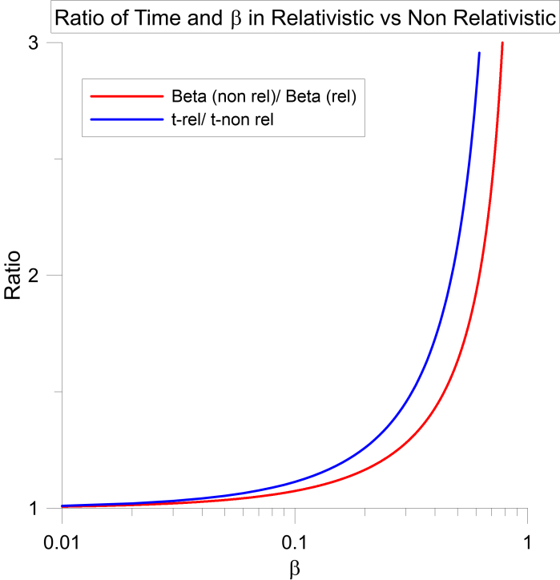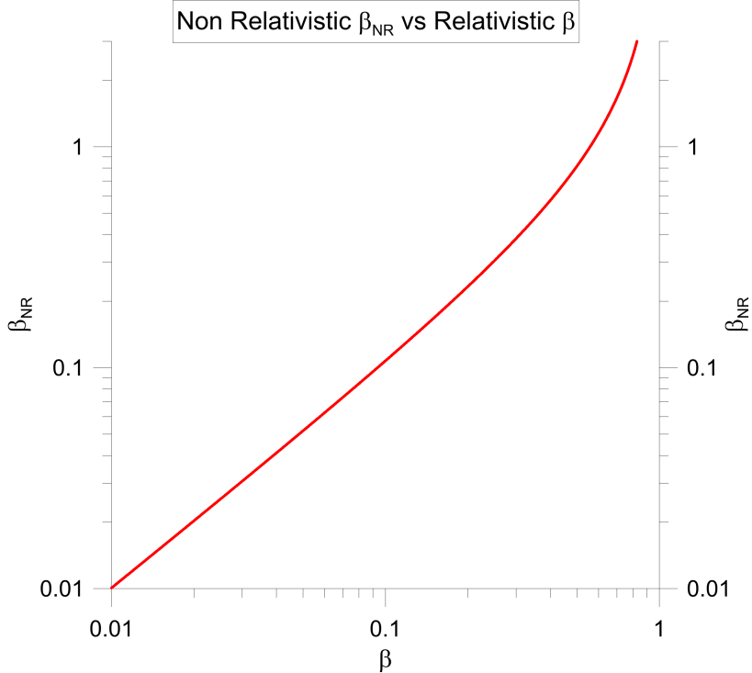

Using conservation of momentum for the entire photons + spacecraft system we obtain the equations of motion for the relativistic case as:



We can integrate this directly noting that dβ/dt= dβ/dx* dx/dt=cβ dβ/dx. We then get:





This is identical to the non-relativistic limit derived earlier of:



We can rewite the relationship between the correct relativistic speed β0 at L0 compared to the non-relativistic speed β0-NR solution as below. The same relationship holds at any point up to L0. Note that the non-relativistic β0-NR always overestimates the correct speed β0 up to and including at L0.

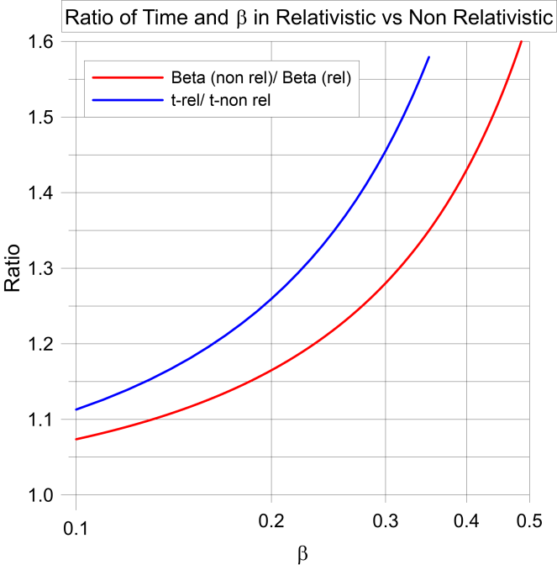

The relationship between the non-relativistic and relativistic solution is particularly useful in that the computations and insight from the non-relativistic solutions are much easier and given the above ratios of t/tNR and β0/β0-NR allow us to compute β0-NR and t0-NR from the system parameters and then translate to the relativistic solution for β0 and t0. For example at β0=0.10 β0-NR is computed at 8% higher than it should be, at β0=0.20 β0-NR is 16% higher than it should be and at β0=0.30 β0-NR is 28% higher than it should be. The full relativistic solution can and is be used but it is less intuitive and often the non-relativistic solution for mildly relativistic systems gives much more insight into a system design. For highly relativistic solutions it is easier to use the fully relativistic solution.

**Optimization of reflector and spacecraft mass in the relativistic limit** – In the non-relativistic limit we showed that the maximum speed is obtained when the reflector mass is equal to the spaceraft mass (Lubin 2015). In the full relativistic case the same condition holds, namely the maximum speed is when the reflector and spacecraft mass are equal [msail = m0] (Kulkarni and Lubin 2016).